Dataset Loaded Successfully.

Patient_ID Name Gender Age Blood_Group Date_of_Admission \

0 P0001 Steve Williams Female 22 AB+ 2025-03-30

1 P0002 Dr. Ronald Faulkner Male 52 B+ 2024-11-21

2 P0003 Susan Wagner Other 77 B+ 2024-09-23

3 P0004 Brandon Lloyd Female 47 AB- 2024-08-24

4 P0005 Michele Guzman Other 78 A+ 2025-04-25

Doctor_Name Hospital_Name Insurance_Provider \

0 Dr. Ahmed Khan Metro Health Clinic CareWell

1 Dr. Raj Patel Green Valley Medical Center MediCare

2 Dr. Raj Patel City General Hospital MediCare

3 Dr. Ahmed Khan Green Valley Medical Center InsureMax

4 Dr. John Smith Metro Health Clinic MediCare

Billing_Amount Room_Number Discharge_Date Diabetes_Test_Result \

0 7821.59 902 2025-04-06 Negative

1 4222.44 733 2024-11-29 Negative

2 9845.07 970 2024-10-02 Negative

3 6038.32 588 2024-09-01 Negative

4 3344.43 726 2025-05-04 Negative

Disease_Name

0 Heart Disease

1 Diabetes

2 Diabetes

3 Heart Disease

4 Diabetes

Dataset Shape: (400, 14)

Column Names: ['Patient_ID', 'Name', 'Gender', 'Age', 'Blood_Group', 'Date_of_Admission', 'Doctor_Name', 'Hospital_Name', 'Insurance_Provider', 'Billing_Amount', 'Room_Number', 'Discharge_Date', 'Diabetes_Test_Result', 'Disease_Name']

Data Types:

Patient_ID object

Name object

Gender object

Age int64

Blood_Group object

Date_of_Admission object

Doctor_Name object

Hospital_Name object

Insurance_Provider object

Billing_Amount float64

Room_Number int64

Discharge_Date object

Diabetes_Test_Result object

Disease_Name object

dtype: object

Summary Statistics:

Patient_ID Name Gender Age Blood_Group \

count 400 400 400 400.000000 400

unique 400 399 3 NaN 8

top P0384 Joseph Brown Male NaN B+

freq 1 2 147 NaN 71

mean NaN NaN NaN 50.930000 NaN

std NaN NaN NaN 17.234927 NaN

min NaN NaN NaN 20.000000 NaN

25% NaN NaN NaN 36.000000 NaN

50% NaN NaN NaN 51.000000 NaN

75% NaN NaN NaN 65.000000 NaN

max NaN NaN NaN 80.000000 NaN

Date_of_Admission Doctor_Name Hospital_Name \

count 400 400 400

unique 245 5 4

top 2024-06-07 Dr. John Smith Metro Health Clinic

freq 6 91 108

mean NaN NaN NaN

std NaN NaN NaN

min NaN NaN NaN

25% NaN NaN NaN

50% NaN NaN NaN

75% NaN NaN NaN

max NaN NaN NaN

Insurance_Provider Billing_Amount Room_Number Discharge_Date \

count 400 400.000000 400.000000 400

unique 5 NaN NaN 248

top InsureMax NaN NaN 2024-05-28

freq 92 NaN NaN 6

mean NaN 5457.775675 556.600000 NaN

std NaN 2514.714485 257.324026 NaN

min NaN 1016.590000 100.000000 NaN

25% NaN 3388.245000 346.500000 NaN

50% NaN 5418.545000 565.000000 NaN

75% NaN 7636.380000 778.250000 NaN

max NaN 9986.550000 999.000000 NaN

Diabetes_Test_Result Disease_Name

count 400 400

unique 2 2

top Negative Diabetes

freq 211 212

mean NaN NaN

std NaN NaN

min NaN NaN

25% NaN NaN

50% NaN NaN

75% NaN NaN

max NaN NaN

Missing Values:

Patient_ID 0

Name 0

Gender 0

Age 0

Blood_Group 0

Date_of_Admission 0

Doctor_Name 0

Hospital_Name 0

Insurance_Provider 0

Billing_Amount 0

Room_Number 0

Discharge_Date 0

Diabetes_Test_Result 0

Disease_Name 0

dtype: int64

Total Duplicate Rows: 0

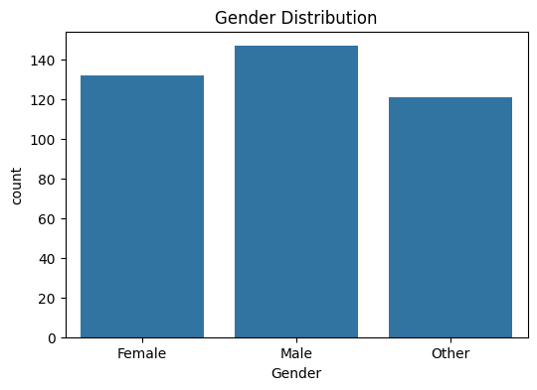

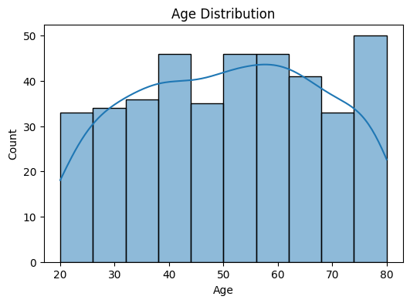

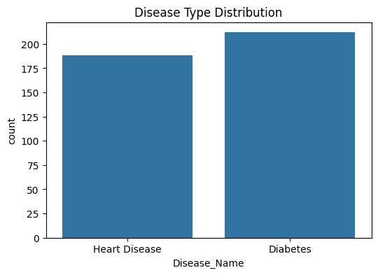

Target Variable: Disease_Name

Features:

['Gender', 'Age', 'Blood_Group', 'Date_of_Admission', 'Doctor_Name', 'Hospital_Name', 'Insurance_Provider', 'Billing_Amount', 'Room_Number', 'Discharge_Date', 'Diabetes_Test_Result']

Gender object

Age int64

Blood_Group object

Date_of_Admission object

Doctor_Name object

Hospital_Name object

Insurance_Provider object

Billing_Amount float64

Room_Number int64

Discharge_Date object

Diabetes_Test_Result object

dtype: object

Accuracy: 0.525

Classification Report:

precision recall f1-score support

Diabetes 0.53 0.76 0.63 42

Heart Disease 0.50 0.26 0.34 38

accuracy 0.53 80

macro avg 0.52 0.51 0.49 80

weighted avg 0.52 0.53 0.49 80

WARNING:pdfminer.pdfpage:CropBox missing from /Page, defaulting to MediaBox

WARNING:pdfminer.pdfpage:CropBox missing from /Page, defaulting to MediaBox

WARNING:pdfminer.pdfpage:CropBox missing from /Page, defaulting to MediaBox

WARNING:pdfminer.pdfpage:CropBox missing from /Page, defaulting to MediaBox

WARNING:pdfminer.pdfpage:CropBox missing from /Page, defaulting to MediaBox

WARNING:pdfminer.pdfpage:CropBox missing from /Page, defaulting to MediaBox

WARNING:pdfminer.pdfpage:CropBox missing from /Page, defaulting to MediaBox

WARNING:pdfminer.pdfpage:CropBox missing from /Page, defaulting to MediaBox

WARNING:pdfminer.pdfpage:CropBox missing from /Page, defaulting to MediaBox

WARNING:pdfminer.pdfpage:CropBox missing from /Page, defaulting to MediaBox

WARNING:pdfminer.pdfpage:CropBox missing from /Page, defaulting to MediaBox

WARNING:pdfminer.pdfpage:CropBox missing from /Page, defaulting to MediaBox

WARNING:pdfminer.pdfpage:CropBox missing from /Page, defaulting to MediaBox

WARNING:pdfminer.pdfpage:CropBox missing from /Page, defaulting to MediaBox

WARNING:pdfminer.pdfpage:CropBox missing from /Page, defaulting to MediaBox

WARNING:pdfminer.pdfpage:CropBox missing from /Page, defaulting to MediaBox

WARNING:pdfminer.pdfpage:CropBox missing from /Page, defaulting to MediaBox

WARNING:pdfminer.pdfpage:CropBox missing from /Page, defaulting to MediaBox

WARNING:pdfminer.pdfpage:CropBox missing from /Page, defaulting to MediaBox

WARNING:pdfminer.pdfpage:CropBox missing from /Page, defaulting to MediaBox

WARNING:pdfminer.pdfpage:CropBox missing from /Page, defaulting to MediaBox

WARNING:pdfminer.pdfpage:CropBox missing from /Page, defaulting to MediaBox

WARNING:pdfminer.pdfpage:CropBox missing from /Page, defaulting to MediaBox

WARNING:pdfminer.pdfpage:CropBox missing from /Page, defaulting to MediaBox

WARNING:pdfminer.pdfpage:CropBox missing from /Page, defaulting to MediaBox

WARNING:pdfminer.pdfpage:CropBox missing from /Page, defaulting to MediaBox

WARNING:pdfminer.pdfpage:CropBox missing from /Page, defaulting to MediaBox

WARNING:pdfminer.pdfpage:CropBox missing from /Page, defaulting to MediaBox

WARNING:pdfminer.pdfpage:CropBox missing from /Page, defaulting to MediaBox

WARNING:pdfminer.pdfpage:CropBox missing from /Page, defaulting to MediaBox

WARNING:pdfminer.pdfpage:CropBox missing from /Page, defaulting to MediaBox

WARNING:pdfminer.pdfpage:CropBox missing from /Page, defaulting to MediaBox

WARNING:pdfminer.pdfpage:CropBox missing from /Page, defaulting to MediaBox

WARNING:pdfminer.pdfpage:CropBox missing from /Page, defaulting to MediaBox

WARNING:pdfminer.pdfpage:CropBox missing from /Page, defaulting to MediaBox

WARNING:pdfminer.pdfpage:CropBox missing from /Page, defaulting to MediaBox

WARNING:pdfminer.pdfpage:CropBox missing from /Page, defaulting to MediaBox

WARNING:pdfminer.pdfpage:CropBox missing from /Page, defaulting to MediaBox

WARNING:pdfminer.pdfpage:CropBox missing from /Page, defaulting to MediaBox

WARNING:pdfminer.pdfpage:CropBox missing from /Page, defaulting to MediaBox

WARNING:pdfminer.pdfpage:CropBox missing from /Page, defaulting to MediaBox

WARNING:pdfminer.pdfpage:CropBox missing from /Page, defaulting to MediaBox

WARNING:pdfminer.pdfpage:CropBox missing from /Page, defaulting to MediaBox

WARNING:pdfminer.pdfpage:CropBox missing from /Page, defaulting to MediaBox

WARNING:pdfminer.pdfpage:CropBox missing from /Page, defaulting to MediaBox

WARNING:pdfminer.pdfpage:CropBox missing from /Page, defaulting to MediaBox

WARNING:pdfminer.pdfpage:CropBox missing from /Page, defaulting to MediaBox

WARNING:pdfminer.pdfpage:CropBox missing from /Page, defaulting to MediaBox

WARNING:pdfminer.pdfpage:CropBox missing from /Page, defaulting to MediaBox

WARNING:pdfminer.pdfpage:CropBox missing from /Page, defaulting to MediaBox

WARNING:pdfminer.pdfpage:CropBox missing from /Page, defaulting to MediaBox

WARNING:pdfminer.pdfpage:CropBox missing from /Page, defaulting to MediaBox

WARNING:pdfminer.pdfpage:CropBox missing from /Page, defaulting to MediaBox

WARNING:pdfminer.pdfpage:CropBox missing from /Page, defaulting to MediaBox

✅ Extracted rows: 0

Empty DataFrame

Columns: [Patient_ID, Name, Gender, Age, Blood_GrouDpa, te_of_Admissi, onDoctor_Name]

Index: []

✅ Saved as /content/patient_data.csv

Empty DataFrame

Columns: [Patient_ID, Name, Gender, Age, Blood_GrouDpa, te_of_Admissi, onDoctor_Name]

Index: []